38.64: a) In terms of the satellite’s mass , orbital radius and orbital period ,
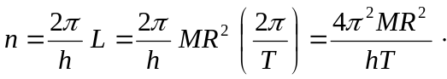
Using the given numerical values, 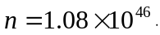 b) The angular momentum of the satellite in terms of its orbital speed 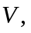 mass, and radius is 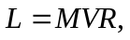so 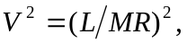and its centripetal acceleration is 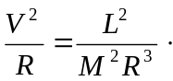
Newton’s law of gravitation can then be expressed as
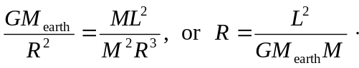
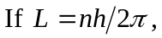
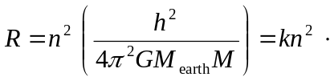
c) 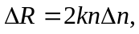 and for the next orbit, 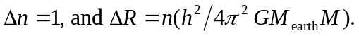 Insertion of numerical values from Appendix F and using from part (a) gives 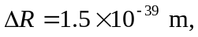which is (d) not observable. (e) The quantum and classical orbit do correspond, either would be correct, but only the classical calculation is useful.

